Creating of Tickets

**1.** Login to 10.10.10.34:8000

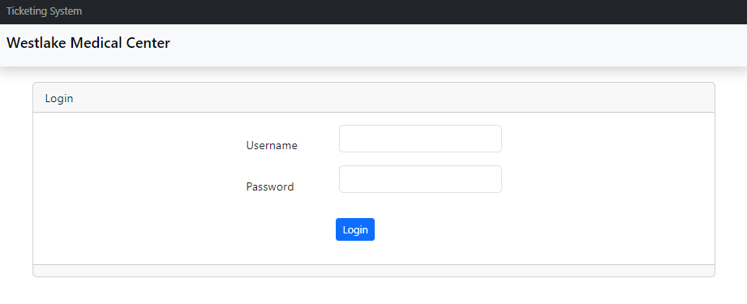

**2.** Click on Tickets

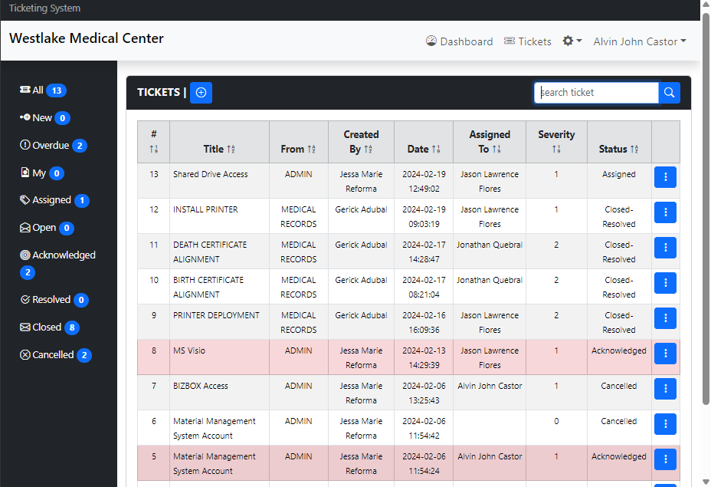

**3.** Click create ticket

**4.** Type your request in the title field

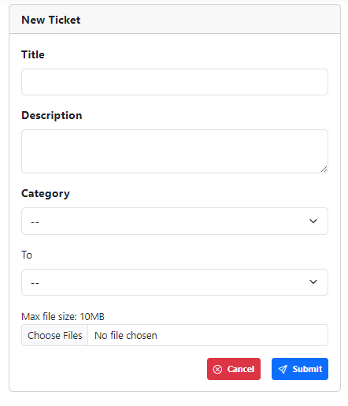

**5.** Type the description of your request



**6.** Select the category of your ticket



**7.** Select the department where you want to send the ticket to

**8.** Click Choose Files if you want to attach any file/s for reference. For multiple files, hold the ctrl button while selecting the files you want to attach. Make sure that the files will not exceed more thank 10MB (Optional)



**9.** Click submit to send the ticket or cancel if you do not want to continue.



**10.** Once ticket is created, your ticket will appear on the list of tickets that you have created. You can view the status and whom it is assigned to.

